ASSIGNMENT
Module (HTML5) – 3
KETAN PILLAI.V
- What are the new tags added in HTML5?
Ans: - HTML5 introduced several new tags and attributes to enhance the capabilities of web development. Some of the notable new tags in HTML5 include:
1. `<article>`: Represents a self-contained piece of content that could be distributed and reused independently.
2. `<section>`: Defines a section of a document, grouping together related content, and typically with a heading.
3. `<nav>`: Represents a navigation menu or links to other pages or sections within the document.
4. `<header>`: Represents a header for a section or page and can include headings, logos, and navigation elements.
5. `<footer>`: Defines a footer for a section or page, often containing metadata, copyright information, or links to related documents.
6. `<aside>`: Represents content that is tangentially related to the content around it, such as a sidebar or a pull quote.
7. `<figure>` and `<figcaption>`: `<figure>` is used to encapsulate media content, such as images, videos, or graphs, and `<figcaption>` provides a caption for the content within `<figure>`.
8. `<main>`: Specifies the main content of a document, excluding headers, footers, and sidebars.
9. `<mark>`: Highlights text within a document.
10. `<progress>`: Represents the completion progress of a task.
11. `<output>`: Represents the result of a calculation or user action
12. `<time>`: Represents a specific period in time or a range of time.
13. `<meter>`: Represents a scalar measurement within a known range.

- How to embed audio and video in a webpage?
Ans: - To embed audio and video in a webpage, you can use the <audio> and <video> elements in HTML5. Here's a basic example for both:
Embedding Audio:
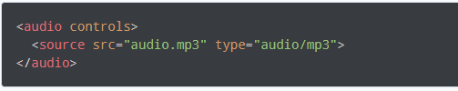
In this example:
The `controls` attribute adds playback controls (play, pause, volume, etc.).
The <source> element provides different formats for cross-browser compatibility.
Embedding Video:
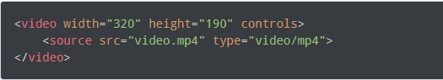
In this example:
The `controls` attribute adds playback controls.
The `width` attribute sets the width of the video player.
Multiple <source> elements can be used for different video formats.
Additional Attributes:
auto play: Automatically starts playback when the page loads.
loop: Enables looping of the audio or video.
muted: Starts the media playback with the audio muted.
- Semantic element in HTML5?
Ans: -Semantic elements in HTML5 are tags that carry meaning about the structure and content of the web page, making it more readable for both developers and browsers. These elements provide information about the sections and content of a page, rather than just defining how the content should be styled. Using semantic elements can improve accessibility.

Here are some of the key semantic elements introduced in HTML5:

1. `<article>`: Represents a self-contained piece of content that could be distributed and reused independently.
2. `<section>`: Defines a section of a document, grouping together related content, and typically with a heading.
3. `<nav>`: Represents a navigation menu or links to other pages or sections within the document.
4. `<header>`: Represents a header for a section or page and can include headings, logos, and navigation elements.
5. `<footer>`: Defines a footer for a section or page, often containing metadata, copyright information, or links to related documents.
6. `<aside>`: Represents content that is tangentially related to the content around it, such as a sidebar or a pull quote.
7. `<main>`: Specifies the main content of a document, excluding headers, footers, and sidebars.
Using these semantic elements appropriately can enhance the structure and meaning of your HTML documents, making them more accessible and understandable for both humans and machines.
- Canvas and SVG tags
Ans: - Both <canvas> and <svg> are HTML elements that allow you to draw graphics on a web page, but they use different approaches and have different use cases.
<canvas> Element:
The <canvas> element provides a bitmap-based drawing surface using JavaScript. It is well-suited for rendering dynamic graphics, animations, and complex visualizations. Here's a simple example:
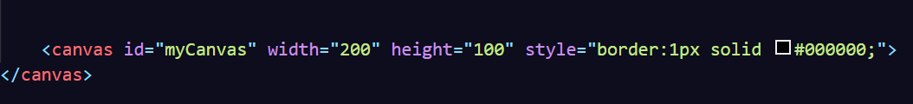
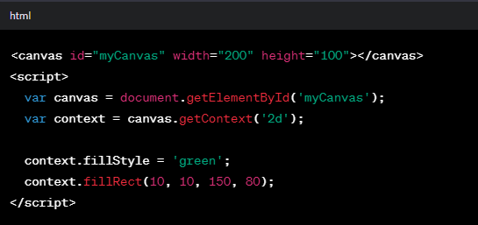

<svg> Element:
The <svg> element is a vector graphics format based on XML. It's suitable for static images, logos, and scalable graphics. SVG graphics are defined as XML elements.
